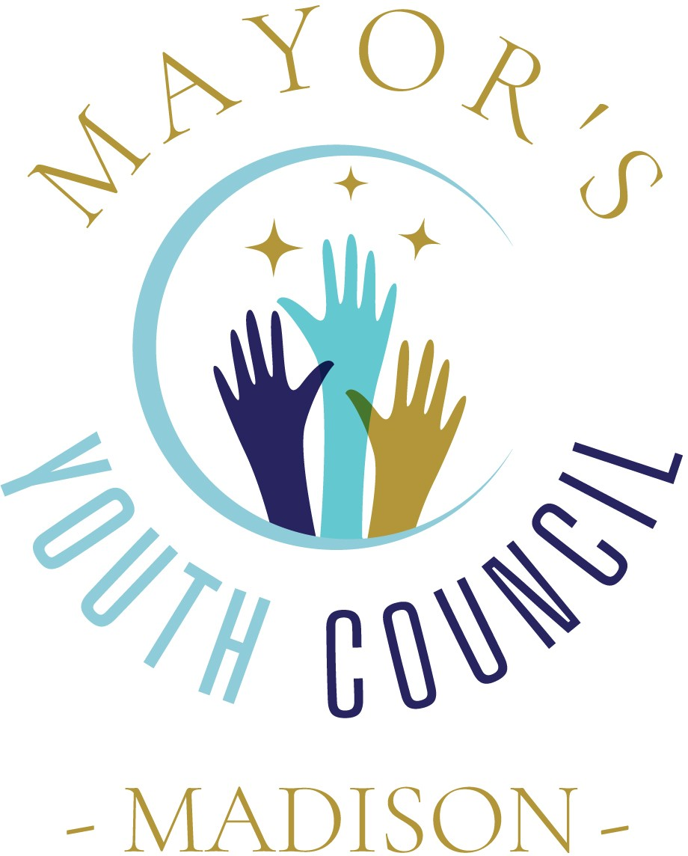
2023-2024
Madison Mayor's Youth Council Application
10th-12th grade
(Madison the City schools only)

Please return to Amy Cummins - Community Partners with a letter of reference by
July 1,2023. (NO EXCEPTIONS)
by mail PO Box 40 - Madison, MS 39130 or drop off at 2023 Main St. (church next to Half Shell)

Please contact Amy Cummins at acummins@madisonthecity.com or 601.856.7060 with any questions.

SECTION 1

PERSONAL INFORMATION

Name:

Address: Zip Code:

Email:

Cell Phone:

Birthday: Age:

What school will you attend in the fall of 2023? Grade level fall of 2023:
How did you hear about this program?

SECTION 2

COMMUNITY/SCHOOL ACTIVITIES

Describe any activities you have been involved with in or outside of school. Some examples include: extracurricular activities, service-learning projects, school projects, leadership opportunities, community organizations, youth groups, sports, etc.

Short Answer: (150-250 words)

What motivates you to join the Mayor’s Youth Council? What skills, experiences, or talents do you possess that would be helpful in your work on the Mayor’s Youth Council?

SECTION 3

What programs would you like to see in our community, and what could you do to help bring this program to the community?

If you had the opportunity to coordinate a community service project for Madison, what would it be? How would you make it happen?

SECTION 4

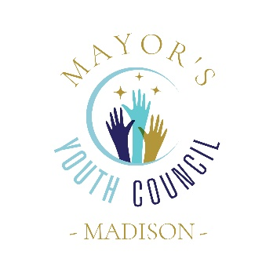
The following requirements are expected to remain in good standing.

Meetings are held the 2nd Tuesday of each month from August to April @ 5pm. (in some instances it may be necessary to change a time/date)

*Must attend 4 of the 9 monthly meetings.
*Attend 1 city board meeting. (Held 1st and 3rd Tuesday of each month)
*Help build a scarecrow for Oct Scarecrow project (will be part of a team)
*Volunteer for at least 1 city of Madison event

All points must be obtained by April 30, 2024.
2200 points are required to be considered in good standing and are required to apply for the next year.
3000 points are required for seniors wishing to apply for a scholarship.

If not in good standing, your name will not be submitted to your school counselor for awards day.

*I understand what is being asked of me to be a part of the Madison Mayor’s Youth Council and what is expected of me to remain in good standing.

Student Signature _______________________________Date____________

*I understand what is expected of my child to be a part of the Madison Mayor’s Youth Council and what is expected of him/her to remain in good standing.

Parent Signature ________________________________Date____________

